Project Loan Model Update for LIHTC

Summary:
This update improves the accuracy on voluntary prepay projection (CRR) for project loans whose underlying property receives Low Income Housing Tax Credit (LIHTC). In general, project loans with LIHTC tend to prepay slower before the tax credit compliance period ends (year 15). After year 15, the speed returns back to approximately the same level as other project loans.

Algorithm:
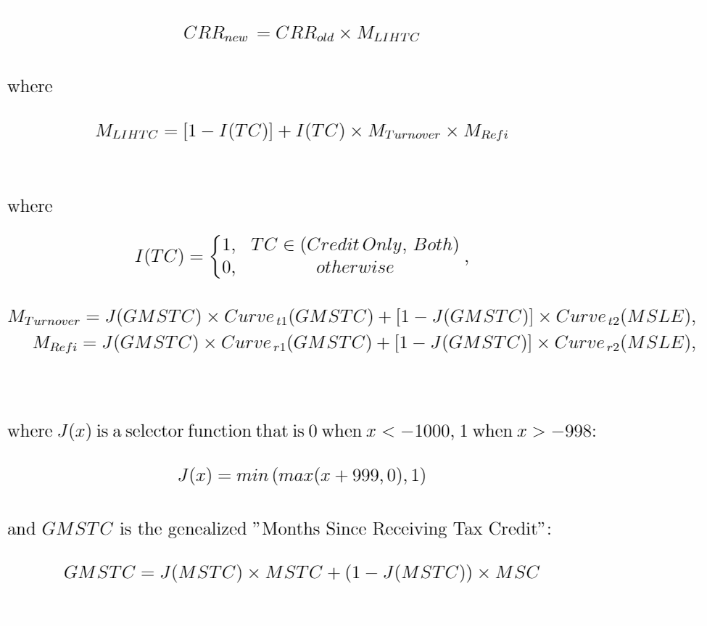

Variables:
TC (tax credit flag):
We use the categories under “Tax Incentive” (“Credit Only”, “Exemption Only”, “Both”, “None”).
GMSTC (generalized months since start receiving tax credit):
This is determined as following:
- When MSTC is available (not -99999), use MSTC;
- Otherwise, when MSC is available (not -99999), use MSC;
- Otherwise, use -99999
MSLE (months since lock-out period end):
This is calculated as the difference (in months) between the date when the lock-out period for the loan ends and the factor date
MSTC (months since start receiving tax credit):
This is calculated as the difference (in months) between the date when the property start receiving LIHTC (TC Start Date) and the factor date. This requires a mapping between GPL loans and LIHTC properties, which cannot always be found. In such missing case, use -99999.
MSC (months since CL conversion date):
This is calculated as the difference (in months) between the date when the original CL loan converts and the factor date. This requires a mapping between current GPL loans and their original CL loan, which cannot always be found. In such missing case, use -99999.
TC Start Date:
This is the latter of “LIHTC Allocation Date” (yr_alloc) and “Place In Service Date” (yr_pis) from the project_loan.lihtcpub table. For the month part, assume Jul-01 (middle of the year) for now.

Curve Description:
Curve_{t1}:
This is the turnover curve for the case when we know either MSTC or MSC. The x-axis is “Months Since”. The shape of the curve is a spike around year 15, where the LIHTC loans tend to have high non-incentive driven prepayments. Before year 12, the curve is close to 0. Around year 15, the peak is around 1.5. After year 18, the curve returns to 1.
Curve_{t2}:
This is the turnover curve for the case when we DO NOT know either MSTC or MSC. The x-axis is “Months Since”. This is a ramp that starts with a value lower than 1 and converges to 1 around month 80.
Curve_{r1}:
This is the refinance curve for the case when we know either MSTC or MSC. The x-axis is “Months Since”. The shape of the curve is a ramp that starts with a value lower than 1 and converges to 1 around year 15.
Curve_{r2}:
This is the refinance curve for the case when we DO NOT know either MSTC or MSC. The x-axis is “Months Since”. This is a constant function with a value between 0 and 1.

Appendix A:
Database Tasks
- HUD Tax Incentive Data
  - The dataset updates monthly: https://www.hud.gov/program_offices/housing/comp/rpts/mfh/mf_f47/
  - We need a check job that runs after the monthly HUD Tax Incentive downloading job. This check job checks for the change in status against the previous month’s load. The check result will be a report that shows the change in status for each pool.
Example Check Report (first 10 rows from 2/7/2019 to 2/14/2019 HUD update):
With impact on model:
poolNumber | OrigStatus | NewStatus
BH4360X | N | B
BH2538X | N | B
AI9453X | N | TC
BH6893X | N | B
BK2378X | N | B
BF5037X | N | B
BH5801X | N | B
BI1378X | N | B
BH2551X | N | TC
BF5035X | N | B
With no impact on model (no record):
poolNumber | OrigStatus | NewStatus

  - Once the new tax incentive labels are approved, update the “Tax Incentive” column of “Scale.gpl_pool_intex” table with the latest.

- LIHTC Data
  - HUD last update in 2016: https://www.huduser.gov/portal/datasets/lihtc.html
  - This table is already loaded into project_loan.lihtcpub
  - Currently we don’t need a process to check for updates automatically, given this table hasn’t been updated for more than 2 years.

Step 3-5 has to be done for all existing GPL loans and any future GPL loan added:
- Property Name / Property Address update
  - Create a clean version of the property name and property address from the project_loan."HUDSummary" table, store them separately from the original names
  - The example cleaning script can be found here: S:\IT\TMP\Hongzhuo\GN PL IO\LIHTC\sql script\Property Name - Address Clean-up.sql
- GPL loan to LIHTC mapping
  - With the clean address / clean property name we created from task 3, we need to update the mapping table between the LIHTC property table (hud_id) and the GPL loan table (fhaNumber)
  - The sample mapping script can be found here: S:\IT\TMP\Hongzhuo\GN PL IO\LIHTC\sql script\LIHTC - Loan mapping.sql.
- GPL loan to original CL loan mapping
  - With the clean address / clean property name we created from task 3, we need to update the refi mapping table that maps a refi project loan to its CL loan.
  - The sample mapping script can be found here: S:\IT\TMP\Hongzhuo\GN PL IO\LIHTC\sql script\Refi - Orig Loan mapping.sql (This script uses “property name” as the primary criteria to match, and “property address” as secondary)

Appendix B:
CDU Update:
- Add field “Tax Incentive”:
  - “TaxIncentive” column from table Scale.GPL_Pool_Intex
- Add field “Generalized Months Since Receiving Tax Credit” (GMSTC):
  - For loans whose “TC Start Date” (discussed above under the variable section) is known through LIHTC property mapping, this field is calculated as month difference between the “TC Start Date” and the factor date
  - Otherwise, for converted Construction Loans, this field is calculated as the month difference between the issue date and the factor date
  - Otherwise, for Construction Loans not converted (CL) yet, this will be a negative number that is the difference between the projected conversion date and the factor date
  - Otherwise, for non-Construction Loans whose CL loan is found through refi mapping, this field is calculated as the month difference between the original CL conversion date and the factor date
  - Otherwise, use -99999
- Add field “Generalized Months Since Receiving Tax Credit - Category” (GMSTC-Category):
  - For loans whose “TC Start Date” is known through LIHTC property mapping, label as “MSTC”
  - Otherwise, for Construction Loans, label as “MSC”
  - Otherwise, for non-Construction Loans whose CL loan is found through refi mapping, label as “MSC”
  - Otherwise, use blank
- Add field “Months Since Lock-out Period End” (MSLE):
  - “monthsSinceLockOutEndDate” column from table Scale.GPL_PoolHist_Intex

The MSC works as an alternative to MSTC in the case when MSTC is not available. The motivation is that a property usually gets LIHTC approval before construction, but doesn’t start receiving LIHTC until the property is placed in service. That is about the same time when a construction loan converts. Therefore, the original CL conversion date can be a good approximation for TC start date.
Using property address for matching refi loans is not a reliable solution. It can introduce noise when different loans share the same address. This is most frequently seen when a project has multi-phases and/or several loans. To avoid this type of situation, the script does some special handling when trying to match the address. *The same issue happens with geographic coordinates as well.
Note that this number can be negative (not -99999) in the case when the LIHTC is applied for after the property is already in service, or when the property applied for another term of LIHTC to cover additional expenses after certain years. It is also possible that the mapping between the LIHTC property and the loan is incorrect.

